15.389C Global Entrepreneurship Lab: Global health delivery

December 16, 2009
Michelle Bernardini, Josh Gottlieb, Mike Irwin, Tessa Strong
Muthaiga Pediatrics
Interim Research Report

Contents
Executive Summary 2
Problem Statement 3
Overview of Analytical Frameworks 5
External Research Resources 6
American Academy of Pediatrics 6
Pediatric Clinics of North America 10
PhysiciansPractice.com® 11
Analysis of host provided resources 12
Eclipsys PeakPractice EHR/PM™ 12
Standard Operating Procedures 13
HR Documents 14
Benchmarking Against World-Class Clinics 15
Comparison Clinics 15
Madison Pediatric 15
Greenwood Pediatrics 15
Affiliated Pediatrics 20
MIT Pediatrics 20
Boston Medical Center (BU) 25
Children’s Hospital Primary Care 25
The Whole Child Center 26
CHOP Philadelphia Primary Care 27
Country, industry, and organizational analysis 27
Country 27
History, culture, society, politics 29
Public health 31
Disease or health focus 35
Appendix 37
Interview framework 41
Patient Processing 41
Clinical Care / Business Process Standardization 41
Resource staffing: 43
Other services provided by clinic 46
Bibliography 47

Muthaiga Pediatrics
Interim Research Report

Executive Summary
Our team has been tasked with enabling the Muthaiga Pediatric Clinic to increase the efficiency and effectiveness of its patient care in preparation for future expansion. To this end, we are currently engaged in gathering best practices from a number of top US clinics by conducting field interviews with medical staff and management. In addition, the team has reviewed leading clinical journals and pediatric association materials to identify the practices of a model pediatric clinic. We have also reviewed Muthaiga Pediatric Clinic’s current practices as laid out in their documents for standard operating procedures, job descriptions, and software manuals in order for us to conduct a gap analysis.
Our interim findings are organized by source and subject throughout this document with supporting documentation attached in the Appendix. While it would be premature to make any recommendations at this interim point, this document serves as a reference of ideal practices at multiple clinics and a compilation of the body of knowledge we have gathered to date. We plan to draw extensively on this foundation while we are in Kenya, and tailor the ideas and strategies presented here for the unique environment, culture, staff, and patient demographics that we find onsite.

Problem Statement
The theme of issues facing Muthaiga Pediatrics at this time revolve around staff and process efficiency. In short, the clinic aims to develop more efficient processes to help serve more patients more effectively and to function as a model for future potential expansion both locally and regionally. The primary mechanisms they wish to investigate are best practices around resource staffing, administrative patient processing, and standardized procedures for patient care. Additionally, they wish to investigate expansion by including sub-specialties within the framework of their clinic, and possibly even on the premises and sharing administrative staff. They further wish to address incentives to staff which can encourage a culture which is overall more attuned to efficiency. Finally, our host later added an interest in understanding the mechanisms behind developing successful brand continuity, such that patients understand what the clinic represents on a level greater than any one provider or practitioner.
Consequently, we aim to deliver results which map directly to the items delineated above. Namely, we intend to offer a collection of presentations representing the standards and best practices we’ve discovered in our research of standards bodies and comparable clinics, along with our ideas and research conducted on-site into cultural improvement and the feasibility of various sub-specialty expansion options. More specifically, we anticipate delivering a presentation detailing best practices for resource staffing, including an optimal organizational chart for an efficient clinic; a presentation demonstrating best practices for patient processing, including a flow chart based on the end-to-end care process at both researched clinics and Muthaiga; several forms to help the Muthaiga staff with standardizing clinical treatment and making doctor-patient interactions more efficient; as well as reflections on our experiences investigating the current culture in the clinic with suggestions for improvement, and our thoughts on the relative merits of adding subspecialties to the current structure.

To summarize our intended deliverables:
- Best practices from comparable clinics and standards bodies relating to resource staffing (presentation)
- Potential organizational chart for clinic, which utilizes more efficient training and hierarchies to see more patients more effectively (organizational chart)
- Best practices from comparable clinics and standards bodies relating to patient processing (presentation)
- Flow charts of end-to-end patient movement from clinic entry to exit, under the current system and under a proposed, ideal system (flow charts)
- Form for entry of standardized clinical treatment to be performed by (non-doctor) staff, based on symptoms and patient history (form)
- Standard form to summarize observations of a given patient from initial staff interaction to the doctor to help make the doctor-patient interaction more effective (form)
- Suggestions for improving culture and encouraging efficiency at the clinic (presentation / interview results)
- Results of our team investigation around the possibility of adding subspecialist facilities to the clinic in its current location (interview results / recommendation)
We believe that in delivering our results to Muthaiga, we have the potential to effect change within the organization in a real and lasting way. Our presentations on staffing and patient processing, and the addition of standardized forms to the patient care process should give a clear implementation plan for how to create a more efficient end-to-end care system through standardization techniques, as well as how to maximize staff time toward the goal of seeing more patients more effectively. Further, our ideas around improving the culture and incentivizing efficiency at the clinic should catalyze the office to create a healthy work environment, which can in turn enable more effective recruitment and retention of talented key staff members. Finally, our investigation into adding one or more subspecialty clinics to the current structure will give our hosts a clear plan for expansion in the coming years. We anticipate, as per discussions with our host, that we may be able to impact other, non-profit organizations through our suggestions and research as well.

Overview of Analytical Frameworks
Our main goal is process improvement within the clinic, which requires determining best practices followed by implementing those practices when we arrive in Kenya. Best practices are identified through a combination of field interviews, researching journals, academic studies, and professional guides.
Field interviews are conducted with representative U.S. pediatric clinics identified through a combination of host recommendations, mentor suggestions and team research. Discussions follow an interview guide organized chiefly by the following categories: resource staffing, patient processing, and clinical care & process standardization. The complete interview guide is provided in the Appendix.
Research is focused on reviewing relevant literature on designing and operating a successful pediatric clinic. Key Journals, studies, and guides have been identified through three main sources: the American Academy of Pediatrics, the Entrepreneurs Resource, and Pediatric Clinics of North America.
Once we arrive in Kenya our implementation will center on finding the right balance between efficiency, effectiveness and viability. Efficiency will be measured quantitatively by the number of patients processed and the average time taken to perform given tasks. Effectiveness can be measured by the quality of care (e.g. customer satisfaction scores and average waiting time) and the accuracy of each process (e.g. number of errors in billing and scheduling). Viability will be determined by assessing the alignment of the staff’s capabilities with the end requirements for sustainable implementation. For instance, if certain improvements would require additional nurses or pediatricians, such recommendations would not be immediately viable given the long timeline required for bringing on such staff.
We have developed a conceptual diagram (below) to frame our approach to this project and depict the dynamics between the various system components including our team, our resources and other stakeholders. In addition, we have included a copy of our initial work-plan in the Appendix.
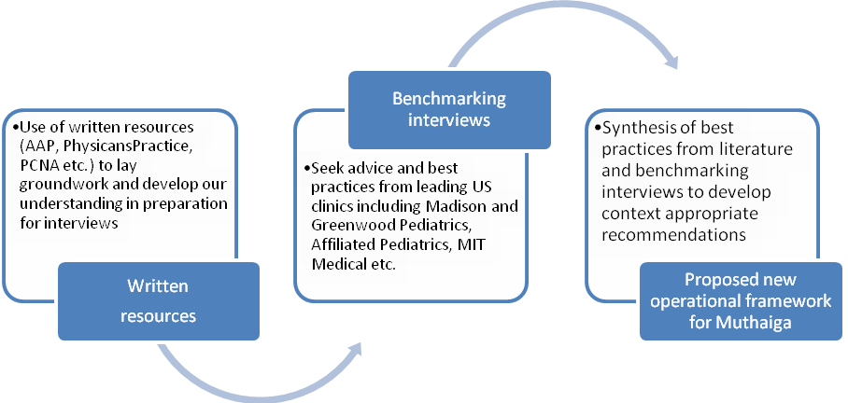
FIGURE 1 CONCEPTUAL DIAGRAM OF PROJECT PROCESS

External Research Resources

American Academy of Pediatrics: We were able to gain access to a valuable series of online pediatric practice management resources (www.aap.org) through the network of one of our team members. The following research was extracted from AAP and will inform our analysis for Muthagia.

Hiring quality staff
- Do not panic hire
- Try to hire a mix of personality types (introvert/extrovert, people-oriented/number crunchers)
- Be open to people outside the medical field: hire people, train the job
- Tell them up front that maturity is expected, in addition to loyalty, honesty, and cooperativeness
- Test at hiring on basic skills: adding/subtracting/alphabetizing, etc
- Have trusted staff be part of interviewing process
- Understand that some will be mistakes and will need to be replaced going forward
- Ask open-ended, behavioral questions to reveal maturity level, work habits
- For nursing staff, be sure of adequate training, personable-ness, and knowledge of limitations
- Have nursing candidates shadow existing staff to be sure they understand expectations, and allow current staff to offer feedback = morale building.
- Make good use of NPs:
  - Nurse practitioners can function as physician extenders (with collaborating physician at primary practice site)
  - NPs can be used to focus on well-child care or urgent cases and can keep people coming in who would not have the patience to wait so long for a physician
  - Use NPs individual strengths (additional education/training) for topic-specific counseling or individualized patient plans.
  - NPs can also function to audit practice policies and management across offices; can be put in charge of new systems integration/training
  - NPs can also represent the practice at schools, community events, and child advocacy boards and can increase patient population or champion messages around nutrition, exercise, immunizations, etc.

Managing Staff
- Hire a practice administrator if the practice doctor only finds direct patient interactions to be rewarding
- Have regularly scheduled meetings with key staff and take them seriously (don’t be late or hurry off early)
- Follow an agenda for each meeting with action items and documented progress on each endeavor
- Distinguish urgent tasks from important ones
- Have the office manager complete a standard template report each week, with highlights written somewhere week to week (color code to notice what is new)
- Always acknowledge these reports, and respond with comments as required
- Keep templates simple, but focus on both short and long-term goals

Job Descriptions
- Job descriptions should establish lines of authority and define the duties of each position
- Front office staff: sign-in receptionist, file clerk, bookkeeper, insurance clerk, sign-out clerk
- Back office staff: nurses, medical assistants, lab personnel
- Include: position/title, basic functions, duties/responsibilities, qualifications, principal working relations (alone v. with others), standards of performance (evaluation metrics- qualitative and quantitative), physical requirements, work environment overview
- Individual job descriptions for specific positions available on AAP site

Office Forms
http://practice.aap.org/sampleofficedocs.aspx

Performance Evaluations
http://practice.aap.org/content.aspx?aID=2201
http://practice.aap.org/content.aspx?aID=2203

Training Staff
- Have 30, 60, and 90 day reviews for new hires, asking if they are making your job easier or harder
- Accept that initial turnover may make your practice stronger in the long term

Office Managers
- Medical managers need to have professionalism, leadership, communication skills, and organizational/analytic skills for problem solving, decision making, and development/administration of day-to-day issues and long-term improvement needs
- Ultimately responsible for the successful functioning of the office, with constant vigilance and frequent participation
- Additionally, they should have technical and professional knowledge to apply to the following fields:
  - Financial management- develop office financial procedures, protocols, and controls; coding/compliance policies; fee schedules; vendor contracts; and compliance with tax/compensation laws
  - HR- manage compensation/benefit plans; oversee recruitment, training, and performance evaluation
  - Governance/organizational dynamics- facilitate physician acceptance of management practices
  - Planning and marketing- monitor and evaluate effectiveness of strategic, business, and marketing plan activities
  - Information management- facilitate informational system procurement, installation, and evaluation
  - Risk management- legal compliance; appropriate record keeping; personnel confidentiality policies
  - Business/clinical operations- analyze staffing levels and scheduling; establish patient flow process; manage material procurement and inventory procedures; implement staff/patient communication systems

Back Office Standard Procedures
- http://practice.aap.org/content.aspx?aid=2034&nodeID=1110

Efficient Office Design
- Waiting room / reception area should resemble a living room and be well-marked
- Number of chairs = max number of patients + 50% for relatives/friends. Space should be = to chairs * 20 sq ft.
- Separate sturdy chairs over couches, light colors/decorations, toys/books for children, display patient artwork on bulletin.
- If space permits, separate rooms for sick and well-child visits (can partition reception area) with clear designations
- 3-4 exam rooms per pediatrician
- Exam rooms large enough for exam table, medical equipment, chairs, and those in the room = 8x10 for infants/young children, 12x12 for adolescents
- Do not need scale/sink in each room, but need cabinet and place to dispose of hazards, along with doors and soundproof walls
- With EMR, ensure that system is placed so doctor can always face the patient
- Allocate ample space for EMR/computer system
- EMRs may be used instead at “dictation pods”, namely standing-room only areas off the main exam hallway for physicians/staff to use quickly between patients
- Nurse stations: 1-2 assistants should have 70-100 sq ft. Add 20 ft for each additional assistant
- Area should have storage for supplies/equipment and fridge to store meds, immunizations, etc. May also place a computer system there

Marketing a practice
- Potential strategies:
  - Community involvement – corporate sponsor of local events, meet local obstetricians/gynecologists, meet local school nurses, write health column for local paper, speak to mothers’ groups, do something unique in the community, conduct talks at local public library on common medical subjects
  - Word of mouth – follow up calls (from doc or nurse) on the day following any sick visit, consider office hours 7 days a week, consider home visits for first well-child visit
  - Advertising locations – pharmacies, schools, child care centers, local baby/mother fairs, local cable station, local newspaper (weekly/monthly article)
  - Other – user-friendly, interactive website catering to children AND adults, use picture of the doctor in ads, pick a brand to represent the clinic and hammer home in ads via repetition, try to be on front or back cover of paper

Patient Satisfaction
- Patient satisfaction is the number one element in building a clinic’s brand
- Patients continually ranked empowerment through education and being informed of their rights/options as key elements in satisfaction (avg score of 84.9 vs 81.2 Press Ganey)
- This includes information about negative outcomes, organ donation, and end of life decisions
- Practically, ask patients how you could make visits more comfortable, and how you can improve your care and service
- Always check to be sure patients’ questions have been answered before leaving an exam room (can even encourage them to bring a list of questions to each appointment).
- Summary: communication, discussion of rights, and engendering trust create loyalty and referrals

Pediatric Clinics of North America: This journal features articles from a variety of topical issues and guidance for the field of pediatrics including a series of articles discussing the actual process used by some hospitals and clinics to identify and implement changes to improve patient care (http://www.pediatric.theclinics.com/current). The team plans to experiment with several of these methodologies including continuous process improvement, value stream mapping, and rapid process improvement workshops while in Kenya.
Continuous Process Improvement
- Seattle’s Children Hospital adopted the principles of Continuous Process Improvement (CPI) and the Toyota Production System (TPS) to improve the quality of care for their patients.
- “CPI aims to eliminate the unnecessary work of no value to the patient, to reduce the necessary work of no value to the patient, and to improve the value-added work we provide to patients”

Value Stream Mapping
- Map the process of a patient – from the patient’s perspective - through diagnosis, therapy, and care until the medical care is completed
- Refer to the map to identify waste through the eyes of the patient. A prime example of waste is waiting. Other examples of waste are:
  - Processing – e.g. form and signature redundancy
  - Correction (re-work)
  - Searching – when information, materials, or equipment are not immediately nearby
  - Transportation – unnecessary movement of staff, goods, or patients
  - Underused staff – due to unnecessary peaks or valleys in patient processing or other activities
  - Poorly used space
  - Inventory – potentially due to unnecessary variation in activity
  - Complexity – lack of reliable methods and standard work

Rapid Process Improvement Workshop (RPIW)
- Bring together relevant staff on a team which designs and implements a process change within a five day period, using the following steps:
  - Watch the actual current process on site
  - Map and quantify the steps involved in the process
  - Determine which steps are useful and which can be altered or eliminated
  - Design and implement the improved process during the week
  - Constantly measure and refine the process thereafter
- The problem to be solved must be tied to some data which can be collected to assess the impact of the initiative
- Data collection must be hard-wired into the everyday responsibilities of the frontline staff. If data is gathered less frequently (i.e. monthly) it is more likely to eventually discontinue.

PhysiciansPractice.com®: PhysiciansPractice.com is a practice management web site used globally by clinicians and their staff to inform business management decision relating to operating a clinical practice including staffing, budgeting, billing, collections, work processes and strategy. The site provides a question and answer forum, relevant articles from Physicians Practice, and customizable forms.
PhysiciansPractice has a series of online tools including models and frameworks to enable a clinic to calculate and track key performance metrics and benchmark itself against a standard. We have adapted a number of these tools to test onsite with Muthaiga including a lab test tracking spreadsheet, and financial models to assess the clinic’s overall financial health and collections efficiency, and to perform overhead, workload and administrative staff benchmarking. In addition, we have sourced several forms that can be tailored on site for Muthaiga’s needs including patient sign-in, information, and visit documentation forms (for general, established, in-patient and out-patient visits), a surgery scheduling form and a patient satisfaction survey. A draft visit documentation form is provided in the Appendix to provide a sample of the format and level of detail in these forms.
We believe that implementing more regular and formal feedback mechanisms to motivate and track administrative and clinical staff performance will become increasingly important as the clinic grows. As such, we have administrator and physician performance evaluation forms which we believe will be particularly useful for Muthaiga and which we will include in our final portfolio, as appropriate. In considering the use of performance evaluations, we will need to better understand the culture and environment at the clinic and in Kenyan healthcare practice generally, to fully appreciate the feasibility of instituting a performance review system.

Analysis of host provided resources

Eclipsys PeakPractice EHR/PM™
Muthaiga Pediatrics has recently made a significant investment by committing to implement a new practice management and electronic health record software system from Eclipsys PeakPractice. The software will be leased to the clinic with implementation beginning in February 2010. Although IT infrastructure was not an element of our project plan, the team felt it was important to understand the capabilities of this software so that we could help Muthaiga fully leverage their investment. As such, we dedicated time in this initial project phase to better understand the key features of the software. We will strive to make final operational efficiency and effectiveness recommendations that utilize the software, where possible. We have included a schematic of PeakPractices core modules in the Appendix. Our analysis of the software is provided below.
PeakPractice provides a user-friendly, flexible, and modular system to improve work-flow and effectiveness in primary care clinics through information technology. They are quickly becoming a standard in US clinics and are leveraging their platform approach to promote health information exchange between clinics through their proprietary platform. The main utility of programs such as PeakPractice is their ability to coordinate the clinical and business activities of a clinic in order to save time and reduce errors.
The first key feature of the PeakPractice system is its electronic health record (EHR) capability. This feature will allow Muthaiga to retain a patient’s medical history in an electronic file so that it can easily be retrieved and shared by clinicians. This advance is particularly significant for Muthaiga, considering many US clinics have not yet implemented EHRs.
The second key feature is the practice management (PM) module which enables patient registration, eligibility determination, billing and claims, and appointment scheduling. This component of the software has a task-building capability which we believe will be especially important to coordinate the activities of various clinic staff members.
PeakPractice also has a supply chain management element that can track and plan inventory ordering (e.g. consumables, vaccines, instruments, medications etc) to reduce waste and increase efficiency. The team plans to explore supply chain activities when we are on site to determine whether this is an area where we can make recommendations for improvement and add value.
The final three modules that are offered are ‘kiosks’ which enable patients and physicians to access key stakeholder-relevant information through an online portal. The patient portal provides personal health information (e.g. allergies, measurements, prescriptions, history etc) and appointment scheduling.
As previously mentioned, Muthaiga plans to begin implementation in February 2010. Vendor training specialists can develop customized training programs and users can pursue their own training through online self-help and e-learning functions. The team has requested a demo of the software while in Nairobi so we can further familiarize ourselves with its capabilities and visualize how it can be integrated with our recommendations.
Outstanding questions regarding Muthaiga’s potential application of PeakPractice to be addressed on site with clinic employees include:
- How will PeakPractice change their use of IT (i.e. incremental update or paradigm shift)?
- What is the implementation timeline for specific modules of PeakPractice?
- Which module does the clinic expect to have the largest impact on their workflow?
- Who will be responsible for updating the software and providing training?
- How will PeakPractice affect the current supply chain (e.g supply replenishment) and bill procedures, specifically?

Standard Operating Procedures
Dr. Nesbitt provided us with several core standard operating procedures (SOPs) used by the clinic reception in order to familiarize ourselves with their current standard and develop a relevant interview framework for the US clinics. The SOPs will be a key tool that the clinic will use going forward for training and monitoring as well as developing the clinic staff to have personal responsibility and accountability for their actions. A brief summary of the key SOPs is provided here as they will be intimately linked to our final report.

Muthaiga Pediatrics Reception Standard Operating Procedures (SOPs)
- Reception SOP: Detailed breakdown of appointment scheduling, patient registration and check-in processes including codes for types of visits, time length bookings, guidelines on actions to take in certain situations (e.g. sick walk-in) etc.
- Reception bookings flow sheet: One page summary for receptionist of considerations when scheduling appointments (e.g. purpose of visit, time required, etc.)
- Preparation of daily worksheet: One page summary of tasks required to confirm patient file information
- Patient's Registration Form (draft): New patient registration form including contact information and medical history
- Newborn flow process: Form listing action items for newborn processing
- Newborn template: Similar document to “newborn flow process” but organized out by role
- Neonatal exam template: Form to guide neonatal exams
- Flow Chart investigations: High-level chart of actions for participants in a lab investigation
- Adoption template: Summary of tasks for first appointment with newly adopted baby
- Clinic training and guideline & patient information strategy planning sheet: List and deadlines for training for staff and stakeholders

HR Documents
Dr. Nesbitt has also shared several documents with the team used to coordinate HR activities associated with the clinic. These documents clearly describe and delineate job functions within the clinic and also describe a format in which periodic performance feedback can be provided. The aim of these documents is to ensure that employees are knowledgeable of their employers’ expectations and also to enforce a standard of accountability for tasks. Below, the documents and their content are summarized.
- Appraisal for Nesbitt Clinic: Detailed template for conducting appraisals including a section to be compiled by the employee and a separate section to be compiled by the appraiser. Template leaves room for individuals to grade themselves on a scale of 1-10 in addition to writing short answer free form descriptions of their future goals and level of job satisfaction.
- HR Manual: An extensive manual used by the clinic to inform new employees of their rights and responsibilities upon joining the Muthaiga Clinic. Sections also inform employees of the clinic’s approach to appraisals, leave, salaries and promotions.
- Job Description – Office Administrator: Detailed description of the job currently held by Caroline Mbovi. Document extensively describes Dr. Nesbitt’s expectations as well as key performance indicators by which work done in this role is assessed.
- Job Description – Nurse: Form outlining the role and responsibilities of a pediatrics nurse at the Muthaiga Clinic. Form covers duties in several areas of the job, from clinical responsibilities to reporting.
- Work Flow Manual – Cashier: Form developed for the reference of current employee, Hannah Muchui. Forms deliberately outline daily schedule and responsibilities on an hour-to-hour basis.

Benchmarking Against World-Class Clinics
The core primary research conducted by the team is a set of interviews with clinicians and administrators from leading developed world pediatric clinics. The clinics that participated in this study were identified from the host and mentor recommendations and team research and networking. The interview framework that was developed by the team is provided in the Appendix.

Comparison Clinics

Madison Pediatric
Dr. Nesbitt provided a list of several key US clinics that he had targeted for our analysis, one of which is Dr. Gregg Alexander at Madison Pediatric in Columbus, Ohio (http://madisonpediatric.com/). Dr. Alexander is an enthusiastic supporter of the project and after reviewing our GLab project proposal documents, has graciously connected us with another colleague, Dr. Larry Rosen, who he believes can also contribute to the project. Dr. Alexander is the Director for the American Academy of Pediatrics’ “Office of the Future” and is very interested in promoting advances in pediatric practice design and management – an area that is closely linked to our research.
Dr. Alexander took over the practice from a retiring physician several years ago and has put significant effort into redesigning and developing the office by focusing on functional optimization of the space.
Madison Pediatrics provides sick and well child care as well as supporting behavioral issues in children. It is a very busy private office that typically sees between 40-50 patients between the two doctors on a given day; however, they can accommodate up to 70 during the sick season. An experienced physician such as Dr. Alexander can see between 4-6 patients per hour. The two pediatricians each work a 6.5hr shift and stagger their hours so that the office is open from 8am-7pm.
Office layout: Dr. Alexander has invested significant time and energy into the functional design of his office to ensure that it allows him and his staff to work as efficiently as possible while providing a comfortable experience for his patients. He completely redesigned the office in 2006 based on his 25 years in medical practice using 3D architectural design software to make the location fit for purpose and incorporate green elements. In designing an office, Dr. Alexander stressed the importance of considering universal design, the psychology of the use of light and color, contagion and traffic control and ergonomics.
Every exam room at Madison Pediatrics is an exact copy. All of the tables, counters and equipment are organized in the same way and all cupboards and storage areas are stocked with materials in the same location in order to allow the clinician to focus on the patient instead of trying to locate items that they need. It is critical that all design and layout decisions take the child’s perspective into consideration in order to create a child friendly atmosphere. For example, Dr. A had translucent glass panels installed at the base of exam room doors so he could see if there was a child standing directly behind a closed door. He also had custom exam tables built with rounded edges and the base cross-bar removed as it had provided a hiding spot for pediatric patients that was tricky for parents or docs to retrieve them from. All of the exam rooms are labeled by color rather than number since children learn colors before numbers and a percentage of the population is illiterate.
Resource staffing: Dr. Alexander has a staff of 6 including a receptionist, medical assistant, office manager, nursing trainee, registered nurse and a second pediatrician (who was brought on board in August). A brief outline of key job responsibilities is provided below:
Receptionist: Technically a medical assistant but provides very little patient care and is instructed to refer to nurse or medical assistant for any medical advice. Uses Barton Schmitz, a well-known pediatric telephone advice reference book, to determine which questions to ask (note: Pediatric Web also uses Barton Schmitz material in developing their pediatric advice resource). Key responsibilities include scheduling patient appointments, print billing receipts and accepting payment, scanning insurance card and verifying insurance eligibility.
Medical Assistant: The MA provides a combination of administrative and clinical support. She assists with general paperwork, coordinating referral requests, and materials and inventory management. In addition, she performs lab draws, immunizations, and takes general health metrics (e.g. weight, height, vitals). The RN will also perform some of these basic clinical tasks.
Office Manager: The Office Manager is a trained MA that Dr. Alexander is mentoring into an expanded role. This individual is very talented and motivated and has been a key asset to the office since she joined recently. The OM is in the process of formalizing many of the offices procedures and streamlining some of their activities (having all employees document all of their tasks). In addition, she has recently drafted a new employee handbook. She is known as the ‘go to’ person in the office and is also able to provide patient information and education.
Nursing Trainee: This is a new employee who will join the clinic shortly. She is in a nurse training program and Madison Pediatrics has agreed to take her on board to train her in basic medical assistant and office procedures while she is in school to familiarize herself with the medical office environment.
Registered Nurse: The RN started with the office under the previous physician-proprietor. She handles most of the patient information and education issues and patient specific medical advice. In addition, the RN will handle medication requests and non-electronic refill orders.
Pediatrician: Newly hired pediatrician who provides full clinical care but it less seasoned than Dr. Alexander and thus can typically see fewer patients per hour.
Training and Performance Reviews: Madison Pediatrics hires individuals for a position based on their qualifications and people skills. They must possess the appropriate certification for the job (e.g. MA cert, RN license etc). Some clinics may ‘hire up’ by bringing in people with lesser qualifications and providing on-site training to work them in a position higher than what they are initially qualified for (e.g. MA working as nurse). Madison does not follow this practice.

Performance reviews are commonly used in larger practices. As Madison Pediatrics grows, they are planning to institute a more formal yearly evaluation program for training, promotion and compensation purposes. Currently, Dr. Alexander meets with each employee individually every 1-2 months to assess their performance and provide constructive criticism for areas of improvement. This review process has had mixed reviews with employees but has been generally accepted when Dr. A presented it is an opportunity to identify growth opportunities and work together to resolve any challenges.
Recruiting: Dr. Alexander stressed the importance of focusing on the soft skills when hiring new employees. In particular the key factors he finds critical are attention to detail, maturity, reliability, ‘kid-friendly’ demeanor, self-starter, and dedication. He also pays careful attention to how candidates present themselves in terms of their physical appearance, cleanliness, and conversation skills since they will be representatives of the clinic and its brand. He uses previous employer references to provide a 3rd party opinion of the candidate and to find examples of how the candidate has performed and handled situations in the past. He has found that it is also important to ask the candidate’s about their expectations for the position including workload and commitment to gauge whether they would be a good fit.

Patient care
Walk-in policy: Madison Pediatrics does not serve walk-in patients; however, same day appointments are scheduled. Dr. Alexander feels that walk-in appointments inconvenience everyone as both scheduled and walk-in patients are forced to wait longer and clinicians are over-worked. Dr. A recognizes that some clinics will have walk-in hours or walk-in specific days. In this case, the walk-in hours may be restricted to early morning (7-9am) at which point no regular appointments will be scheduled and staff will perform paperwork or other general activities if no patients come in.
Flu shots and vaccinations: Madison Pediatrics does not organize specific flu shot clinics or other vaccination days. The local health department offers free, regularly scheduled flu clinics and it has been found that other flu clinics tend to be poorly attended as a result. However, during flu season a flu shot is recommended to all patients that come in. Vaccinations are combined with well child visits and off-cycle vaccinations are seen by the nurse. The office follows CDC recommendations for routine, scheduled well child visits.
Scheduling different types of visits: Dr. Alexander sees both sick and well children and behavioral issues (e.g. ADHD) on any given day. He prefers to intermingle blocks of sick, well, and behavioral visits during the day. By providing several visits of one kind back to back it allows him to get into a rhythm for dealing with a certain situation, but mixing up the types of visits within a day alleviates clinician boredom. Neither of the doctors would want to do only one type of visit for an entire day. Behavioral visits are usually scheduled later in the day (after 330pm) to accommodate children’s school schedules.
Work flow: Dr. Alexander described the typical work flow of a patient visiting Madison Pediatrics. Staff members carry an electronic writing tablet/slate with them which is networked with the computer system to provide real time updates on patient information and task alerts.
- Patient is registered at reception. The office still uses some paper based registration. The insurance card is scanned by the receptionist and insurance eligibility can be verified for most carriers in real time. Any insurance co-payments are collected up front (‘no dough no show’). The patient is flagged as ‘checked in’ and ‘nurse ready’ by the receptionist.
- Note: Nurse and MA are used interchangeably in this section as either individual can perform these functions. Nurse calls patient back to triage area where he is weighed, measured and his vitals are taken. Patient is then taken to exam room where nurse collects the history of the present illness including any family, social or recent travel issues. The patient is flagged as ‘doctor ready’ by the nurse.
- The doctor will order any necessary lab work or vaccinations during his examination. These requests are registered immediately on the tablet so that the nurse is alerted and can return to provide any follow-up services.
- The patient is given a form with follow-up information which he provides to the receptionist on his way out to book any follow-up appointments.
- The office has been designed with a back door exit that is not currently used. In the future, the doctor will book any follow-up visits in the exam room and send reminder information to a printer in the back for patients to pick up on their way out. This modification will alleviate contagion issues and facilitate better patient flow.
Technology: Madison Pediatrics is one of the most technologically advanced practices in the country. The individual exam rooms do not have computers to avoid kid (and parents!) damaging them. However, the doctors, nurses and MAs have electronic pen tablets that convert to slates which they carry with them and allow them to update and receive information in real time. Madison has implemented PeakPractice to manage their office and they have seen increased efficiencies following its implementation. A brief summary of Madison Pediatric’s current level of usage of the software is provided below.
- Use EMR (scanning old medical records in) and some electronic prescribing
- Use electronic scheduling
- Do not use electronic referrals as major referral hospitals are not set-up for it and prefer fax referrals
- Patient kiosks and patient online are set-up but have not yet been rolled out (2 touch screens set-up at reception; patients will be able to add information to their profile online including medical and family history and book appointments during pre-defined windows (not given full access to schedule); PeakPractice patient interface not ideal)
- Materials/supply chain management not yet implemented (due to issue with software)
- Patient billing is outsourced to an external company rather than being handled in-house
Dr. Alexander is on the client advisory board for Eclypsis (maker of PeakPractice) and has input into new product improvements. The new version of PeakPractice that will be released in 2010 has fantastic capabilities. Dr. A also knows Travis Bond, founder of Bond Medical Group and the original developer and vendor of the software, and he has offered to connect the team with individuals from Bond to provide additional training and resources as needed. Dr. Alexander also cautioned that the implementation of a practice management software system is a long process that can take up to 6-9 months, particularly with a computer illiterate staff. He found the transition easier with his staff by encouraging them to become more comfortable using computers generally by playing around with solitaire and email at home. In addition, planning was key and it was helpful to organize training sessions during which the staff could create ‘dummy’ patients and mock up how they would handle various situations with the system.
Sub-specialities: The primary specialties that Dr. Alexander refers to are ENT, dermatology, pyschiatric/psychology, opthamology, allergy, general surgery and orthopedics. To a lesser extent he also refers to neurology, podiatry, gastro-intestinal, pulmonology (asthmatic), immunology, rheumatology, hematology and oncology. Currently, most referrals are either done over the phone to specialists that are local and familiar with the office, or through a formal fax referral process with the nearest pediatric hospital. Electronic referrals are not used to date, although there is the capability to implement them through their practice management software. Dr. A prefers to organize referrals through a more cordial phone call rather than a formal process. Many specialists rent office space in a professional office building which is sponsored by, and near to, the pediatric hospital. The specialists have regularly scheduled days when they will take patients in their local office.
Dr. Alexander was extremely supportive of Dr. Nesbitt’s concept of integrating other specialists into this practice. In order to alleviate any potential concerns of other primary care providers (PCP) referring their patients to a specialist that was co-located with another general pediatrician, Dr. A suggested pro-actively reaching out to those other doctors to explain the set-up and the educate them that the set-up is intended to provide additional help and support for the specialists and not to ‘steal’ patients from the primary care provider. By involving other PCPs early in the process and ensuring that they are get informed of all interactions relating to their patients, it should be easier to get their buy in to this new system.

Greenwood Pediatrics
Greenwood Pediatrics consists of 19 pediatric care providers in 3 locations in the Denver area. In 2008 they received the “Superior Practice” award from the Medical Group Management Association. The practice is considered to be technologically progressive, having implemented the nation’s first online triage and advice center for parents, “Pediatric Web”, in 2001. The following notes are from an interview conducted with Dr. Dan Feiten, Chief Medical Officer of Greenwood Pediatrics:
Scheduling
Scheduling was by far the biggest problem to solve when growing the clinic, and peak scheduling times remain the largest source of frustration for patients.
- Well visits should be scheduled during the periods when parents are typically calling for their sick children. This way the well visits are already completed by the time the sick patients start to arrive
  - These peak sick phone calls occur at two time periods – first thing in the morning and then in the early afternoon (children’s bodies release chemicals to suppress fever-like symptoms in the morning, and those effects wear off in the afternoon, leading parents to become concerned enough to call in the afternoon)
  - Winter (Oct-April) well visits scheduled for the following time slots:
    - 8:30am-10:00am
    - 2:00pm-3:00pm
  - Summer (May-Sept) well visits scheduled for the following time slots:
    - 8:30am-11:30am
    - 2:00pm-3:30pm
  - There are more well visits scheduled in the summer because less children are getting sick during those months (and more parents tend to schedule well visits during that time)
- Peak phone calls occur on Monday morning and Friday morning. More than 300 incoming calls can occur during the first hour on Monday.
  - All front-desk staff are working the phones during the first hour
  - Several initiatives have been taken to decrease this call volume
    - Encouraging families to call after 9:30am or schedule online
    - Piloting new software which allows patients to page a request for an appointment, so a staff member could have that information earlier in the morning and start scheduled before the phones were manned
- Time per visit varies on sick vs. well visit and based on symptoms
  - Generally speaking:
    - Well visits are 30 minutes
    - Sick visits take 15 minutes on average
  - One week ahead of time, physicians are given a report of the patients scheduled for the upcoming week, along with their symptoms
    - Physicians review the symptoms and estimate the amount of time that will be needed for each appointment
      - 10 minutes for simple visits (e.g. height/weight check)
      - 20 minutes for more difficult visits (e.g. asthma-like symptoms, broken bones, fever, special needs)
    - These estimates are sent back to the front desk to coordinate scheduling for the upcoming week
Staffing
- Greenwood pediatrics uses a unique “team within a team” approach where a team of three care providers is assigned to each individual patient
  - Each team can consist of a pediatrician, a physician’s assistant, and a nurse, for instance
  - A particular patient will always be cared for by that particular team, with the rare exception of a sick visit where they are treated by a physician’s assistant responsible for overflow
  - This approach ensures continuity of care and patient comfort
Recruiting
- When possible recruit experienced doctors who are leaving a current practice. This way you can check their references and they generally bring their patients with them
- Sometimes patients are the best source of new hires, particularly if they are experienced nurses who get along well with the staff
- Only front desk staff are occasionally recruited through newspaper ads
- One “secret to Greenwood’s success” is to have one member of the full-time front desk staff devoted as “new patient coordinator”
  - If a potential new patient calls in to ask about the clinic, the call will be given to that specific coordinator
  - The coordinator is a person with a warm personality who has a wealth of experience at the clinic. They are responsible for answering questions about the clinic and scheduling an initial well visit
Training
- The best results come from using a dedicated trainer (typically a supervising nurse) to give individual training over the course of 1-2 weeks
- Sub-optimal results have occurred in the past from using different trainers, or using a “train-as-you-go” approach
Process improvement initiatives
- Patient satisfaction levels were assessed occasionally using paper surveys. A suggestion box is also used in the waiting area. An email service for surveys is being piloted
- Patient processing time was measured by using individual cards for each patient
  - Each card was stamped with the time when the patient checked in, then when they were brought back to the exam room, then when they left the clinic
  - This process upset the staff, however, who thought they were being evaluated. Communication is critical for convincing the staff that the goal is to improve the process, not to assign blame to anyone
Secrets to success
- Scheduling is extremely important for efficiently processing patients and avoiding running over (previously discussed)
- Having a “new patient coordinator” increases the rate of incoming new patients
- Developing a robust website has increased patient satisfaction and decreased the number of incoming calls
  - An “owners manual for parents” has been made available on the website, which answers basic questions for new parents. This has decreased the number of incoming calls for basic questions
  - Greenwood Pediatrics has an online triage tool which parents can use for inputting their child’s symptoms to know when they should bring their child in to the clinic or to the emergency room.
  - Incoming phone calls have remained steady over 2003-2008 when these web initiatives were implemented. During that same time patient volume increased by 25%. This difference implies that parents are finding answers to their questions online, lowering their need for calling the clinic for questions

Affiliated Pediatrics
Affiliated Pediatrics is a conglomerate of 18 independent pediatrics practices serving Eastern Massachusetts. The APP was founded in 1995 when 5 separate practices joined with the common goal of collaborating to provide superior healthcare and customer service to patients. Today the APP has 85 pediatricians and 30 nurse practitioners serving 22 communities.
APP’s business model is of interest to Dr. Nesbitt. An email inquiry and a follow up request for an interview have been sent to APP, but a response has not yet been received. A second follow up email will go out this week; however, this clinic is not in our top priority categorization as discussed in the Interim Process Note.

MIT Pediatrics
At MIT pediatric clinic, we spoke with Phyllis Winn, the practice manager, who arrived 2 years ago from working in the ER at a Florida hospital and also services the specialties and internal medicine at MIT medical.
General tips on clinic design:
- Have patients come in the front door, register, and be led to room; but leave by a different door with different receptionist for scheduling follow-ups. Why?
  - Crying children (i.e. post shots) coming through waiting area has bad effect on other kids
  - Referrals lose confidentiality at front desk, since everyone can hear
- Don’t underestimate the need for a carriage parking lot out front to leave the waiting room clear!
- Need locking cabinets/drawers in all exam rooms because kids WILL get in
Patient processing highlights:
- In the past, staff was just secretaries and providers, but doctors were always stressed out from overwork and copious documentation efforts
- Current organization (post-consultants) has a triage nurse, 2 secretaries, 2 medical assistants, and 2-3 providers (depending on the day) consisting of one doctor and one NP
- Medical assistants have the job of bringing patients from waiting room to exam room, taking vitals- i.e. height, weight, immunizations, allergies, etc (they have a simple form for this, which we will include in final report), and then entering the information into EMR
- EMR used is Touchworks, from Allscripts- not ideal for pediatrics, but reasonable
- There are no CPUs in the exam rooms due to space constraints and issues with staff having to turn their backs on a patient to use them. CPUs are all outside exam rooms instead
- They tried laptops for the doctors, but found them to be too heavy and the kids were constantly pushing all the keys. Also, smaller laptops were not practical for EMR use
- There are 6 exam rooms (not enough with 3 providers present)
- New system: providers work 2 shifts/day of about 3 hours. One sees sick-child visits and one for well-child visits, then they switch responsibilities at next shift, in order to maintain patient base and take pressure off docs from too many sick-child visits. (old system was just a free-for-all and led to chronic overbooking and unhappy staff)
- Each provider sees approximately 16 patients per day under this system (10 sick and 6 well) = total of 32 patients/day average, or 45 patients/day with 3 providers.
- EMR has been customized to add computerized forms for state/school immunizations/medications, which saves large amounts of time
- Scheduling is done through a separate system (called Flowcast), which is visible on all computers, so medical assistants know when new patients have arrived, and everyone knows the schedule for the day at all times
- Metrics/reporting: a custom report has been built for Flowcast which shows # patients seen, no-shows (usually <2% in pediatrics), and unused time
- Billing is done separately through MIT, so no billing notes included here
- Patient flow:
  - Patient enters to front desk. Receptionist verifies DOB and confirms arrival in Flowcast scheduling system. Receptionist copies insurance card if not MIT
  - Medical assistant picks up patient and leads to exam room, patient is undressed if necessary, and MA takes vitals for entry to paper form and then to EMR. Total time: 7-10 minutes
  - Provider enters and is given form from MA to write further notes on. Provider enters notes/meds etc to EMR between patients, or at EOD if backed up (= source of complaints from providers). Typically, 20 minutes for sick-child visits and 30 minutes for well-child. EMR has templates (6 mo, 12 mo, 2 yrs, etc) to ease documentation for providers
  - Patient to desk only if follow-up needed. EMR sends prescriptions directly to MIT pharmacy (narcotics need paper signature as well), or faxes them to other pharmacies
- Staffing advice:
  - Ensure staff is team oriented (i.e. will do whatever job needs to be done for a patient, even if not technically theirs)
  - Cross-train staff as much as possible (i.e. have MAs sit at front desk during down-time to be familiar with receptionist role)
  - When using an EMR, have patience for non-tech savvy staff (especially providers)
  - Keep flexibility in the patient schedule (in case of new patients, newborns, well-child visits running over, etc). This keeps staff happier and avoids serious scheduling conflicts
Other clinic issue highlights:
- No walk-ins officially, as they add strain to staff, but same day is allowed (they ask for a call first)
- No specific vaccination days or sessions. A triage nurse handles most vaccinations, and for well-child visits, it’s part of the appointment. Also, if several vaccinations are split over multiple visits, the child does not see provider each time
- Flu clinics are the exception to the above rule (they are done separately), due to huge volume
- No specific developmental check or school physicals are done, but more well-child visits are scheduled in August and September for back to school and new patients
- MIT medical has it’s own site, medweb.mit.edu, with pediatrics section featuring general info (dosages, symptoms to look for, etc), along with MA immunization schedules, and a patient history form for new patients (not linked to EMR)
Training highlights:
- Doctors must be pediatricians by training; nurse also must have peds background with 3-5 years experience; medical assistants can be trained and can be taken straight out of school
- A separate IS (information systems) team trains everyone on the computer systems
- MAs have a book of SOPs available on the computer system with procedures for them to do in any situation. Difficult to keep up to date, but useful for substitutes if someone is out sick
- SOPs should be aimed at lower-level staff, but those staff should be aware of processes for those above them so they can prepare and save provider time (i.e. recognize symptoms etc)
- No AAP training—just ad-hoc; but also have emergency response drills a few times a year for the most serious situations (seizure, cardiac arrest) to be sure everyone knows what to do (includes entire office staff) No warning is given ahead of time!
- Everyone is trained in CPR (including receptionists) – more hands are better—so call urgent care right away
- Continuing education: CPR every 2 years; one course/year of their choice (computer or medical)
- Cluster meetings are held once /month over lunch to improve/resolve any issues with agenda in advance collected from the entire staff
- Medication changes are discussed with everyone so that they are on top of discussions with patients—more communication = better
Performance review highlights:
- Annual; structured and based on job description (split up into sections: Teamwork, Clinical performance, Following guidelines, Customer service)
- Practice manager makes notes throughout the year—for use in performance review (rating: not proficient, proficient, or highly proficient) and has funds to split up for people for salary increases (no bonuses).
- Set measurable goals for coming year- ie- one class/year, attendance, any specific areas (immunizations entered to system within 3 biz days)
- Also input to reviews from the providers who work with MAs/secretaries all day long
- Practice manager: “For salaried people, there would be far more bang for the buck from a bonus program”—they could see more patients in the hours they’re here. They only work 28 clinic hours to be full time—so incentives to work more would be valuable
- Director for each unit ranks the providers, and medical director ranks the unit director
Recruiting highlights:
- Posting internally first—internal medical website
- Top 3 recruiting criteria:
  - Customer service skills
  - Reliability (gleaned from references)
  - Computer skills
  - ‘Things that don’t matter’: what school they went to, grades, etc…
- Prospective staff judges clinic on:
  - Brand reputation
  - Shorter clinic hours (28) than other clinics
  - Slightly higher pay scale (for non-specialty providers)
  - Great benefits
Sub-specialties highlights:
- Typically needed for dermatology (i.e. for eczema), eye/ENT, and allergy
- Most clinics do not have subspecialties in the same building, but generally clinics have standard set of referral links—definitely better for everyone to have them in the building
- Practice manager is shared for other specialties as well, but not receptionists/providers, etc. Also have floaters (2 MAs, 2 secretaries) who can work in any clinic area where needed
- Sharing evolved over time to help challenge the practice manager
- The more sharing/cross training you have, the better—so more sharing is a good thing
- Stress between clinics: sometimes around appointment availability—i.e. pediatrics wants to send kid over but the specialty is full—often mediated by practice manager (9 times out of 10, talking to them directly works); also, sometimes secretaries elsewhere send adolescents to the pediatric clinic, which can cause stress
- Overall relationships between pediatric clinic and specialty clinics are friendly
- Multiple (twice/day) patients/day are typically referred to specialists
- Recruiting/retaining dermatologists away from cosmetic fields is a big challenge
- Derm does 32 clinic hours (1 patient/15 minutes = 26 patients/day) because of high demand. Allergist does 12 patients/day (because longer typical visits)
- Challenge is just around finding availability (hence, having clinics in the building are very helpful)

Boston Medical Center (BU)
Boston Medical Center began as Boston City Hospital (BCH) in 1864 and was a major accomplishment for the City of Boston. BCH was the first municipal hospital established in the United States. As a municipal institution, BCH began to provide much needed health care to both the urban poor of Boston and the ever-increasing number of Irish Immigrants entering the city during the mid-19th century. Boston Medical Center, which is the result of the 1996 merger of Boston City Hospital and University Hospital, exists on the grounds of the original Boston City Hospital. In the first 50 years of its existence, BCH did not have a Pediatric Service. Children were admitted to one of the four Medical or Surgical Services in wards that housed adults. With support from the City of Boston, funds were earmarked for a free standing Children's Building, and in honor of the wife of Mayor Curley, the Mary E. Curley Pavilion for Children opened in 1932.

Children’s Hospital Primary Care
Children’s Hospital Boston is the primary pediatric teaching hospital for Harvard Medical School. Children’s has operated since 1869 and has consistently ranked in the top 5 U.S. pediatric teaching hospitals for all 10 specialties. We would like to include Children’s in our research, but have yet to receive a response to our inquiries.

The Whole Child Center
The Whole Child Center was added to the interview list quite late in the semester on the recommendation of one of the other US clinics that we contacted (Madison Pediatrics). As such, the team has just begun to build the relationship with the centers founder, Dr. Larry Rosen, to determine whether there is real value in including them in our data set. This decision will be made in conjunction with Dr. Nesbitt, once he has the opportunity to learn more about The Whole Child Center concept and its relevance to Muthaiga Clinics operations. Communications are scheduled between Dr. Nesbitt and Dr. Rosen shortly and will not be available for the interim deadline. The role of this clinic in our analysis will continue to be pursued throughout December and January and a more comprehensive review will be provided in the final report.
The Whole Child Center (http://wholechildcenter.org) is a self-described “revolutionary pediatric practice, provid(ing) children and families with high-quality, state-of-the-art integrative and ecologically sustainable healthcare.” Uniquely, Whole Child is a clinic with a ‘green’ mission – they are interested in the systems interactions between the environment and healthcare and have attempted to develop a sustainable practice, through choosing ‘green’ materials to build and furnish their office, and employing environmentally friendly processes in their clinical work.

Whole Child has been featured in the media numerous times for their practice management and electronic health records in the US. We feel that the competencies that they have developed in this area could be leveraged to the benefit of Muthaiga Pediatrics.

Dr. Larry Rosen is a general pediatrician focused on providing holistic pediatric care through his primary care clinic, the Whole Child Center, in New Jersey. Dr. Rosen is recognized as an expert in integrative pediatric care and is a founding member and vice-chair of the American Academy of Pediatrics Section on Complementary and Integrative Medicine. Dr. Rosen maintains an integrative pediatrics blog, “The Whole Child”, a link to which can be found on our team’s own blog. In addition to graduating from the New York Medical College and completing a residency and chief residency in pediatrics at Mount Sinai Hospital in New York, Dr. Rosen is also an MIT alum.

CHOP Philadelphia Primary Care
The Children’s Hospital of Philadelphia is a premier pediatrics hospital in the United Sates. The hospital, one of the country’s largest and oldest, employs cutting edge research and technologies to provide exceptional patient care and train the next generations of practitioners.

In addition to inpatient and surgical practices, CHOP also provides pediatric primary care through their Pediatrics and Adolescent Care practices in 22 clinics around Pennsylvania. An interview with Dr. Trudy Heacker has been arranged via a personal contact and will be completed by the week of December 14.

Country, industry, and organizational analysis

Country
Kenya is located on the Eastern coast of the African sub-continent and is bordered by Ethiopia, Somalia Tanzania Ugandan and Sudan (Magical Kenya the Offical Kenya Travel Guide).. A medium–sized country by continental standards, the country spans an area of 56,000 km sq. The country’s official languages are Swahili and English. Its population is over 39 million and 99% of this population is made up of indigenous Africans. The Kikuyu, who reside in northern Kenya, are the single most represented ethnic group. In the course of Kenya’s history, the Kikuyu people have been instrumental in the nation’s social and political development (Kenya Ethnic Groups). Like 80% of the workers in Kenya, the Kikuyu are subsistence farmers. Subsistence farming plays a huge role in Kenya’s economy and every year 50% of export earnings can be directly attributed to the agricultural products including coffee, tea, cotton and cashew nuts. The vast majority of Kenyans are Christian (78%) but other religious minorities, Islam (10%) and indigenous beliefs (10%) are also present (Wikipedia Kenya).

Kenya’s topographical geography is incredibly rich and represents every possible kind of landscape from snowy peaks to arid desert to large inland lakes to granitic hills. Kenya also has large inland bodies of water, which span a total of 10,700 km sq and include Lake Victoria (Magical Kenya the Offical Kenya Travel Guide). Every year, Kenya attracts thousands of tourists who descend in the hopes of experiencing some of the diverse wildlife that make their home in Kenya’s many parks and reserves. While Kenya is known for its ‘big 5’, lions, elephants, rhinos, leopards and buffalo, the annual wildebeest migration is a big draw and the event has been voted by a panel of experts as one of the world’s seven wonders. Kenya’s wildlife is considered a global asset.

Kenya’s GDP is $60.36B which translates to aper capita GDP of $1,711. On the human development index, which aggregates measures including life expectancy at birth, education and standard of living, Kenya scores at 0.581 (148th in the world) compared to the United States at 0.951 (14th in the world). In this index, Libya is considered the most developed African country at 0.818 (56th in the world) and Somalia the least. Using the HDI, which is typically used to rate at what state of development at country is at, Kenya qualifies as a medium-developing country (Wikipedia Kenya). Even so, 58% of Kenyans live below the poverty line and unemployment is at 40% and potentially growing. Further details on Kenya’s social landscape (World Bank Kenya)can be found below.

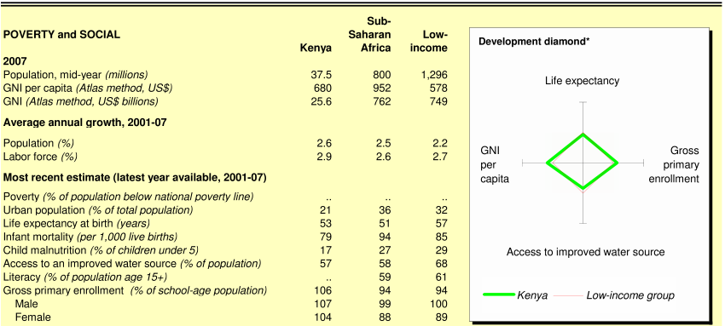
Figure 2 KENYA'S SOCIAL LANDSCAPE: POVERTY AND SOCIAL
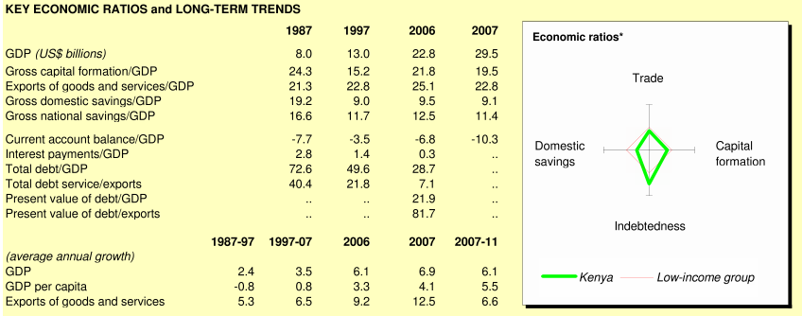
Figure 3: KENYA'S SOCIAL LANDSCAPE: POVERTY AND SOCIAL

Our project will be hosted in the capital of Nairobi, in an affluent suburb called Muthaiga. While Nairobi is home to metropolitan buildings remaining from colonialism, a significant part of the capital city is also populated with slums. Muthaiga is located in a part of town that hosts embassies of nations from around the world. Muthaiga hosts the Muthaiga Country Club, which will be our group’s quarters during our time in Kenya. The club was opened in 1913 and became a meeting point for the elite. Today, many use the country club for its accommodations and facilities, particularly the golf course (Muthaiga Country Club).

History, culture, society, politics
Cushite-speaking people from Northern Africa first moved into the area that is now Kenya in 2000BC. Kenya’s proximity to the Arab peninsula eventually encouraged colonization with Arab and Persian communities sprouting along the east coast of the country in 8th century. By the first millennium, the Bantu and Nilotic people (who now make up 3/4s of Kenya’s population) had moved into the country. As trade in the area grew, Swahili (a mix of Bantu and Arabic) became the primary means of common communication amongst the different people. Later, Arab dominance of the region was overturned with the arrival of the Portuguese (15th century), Islamic control under Imam of Oman (17th century) and the British (19th century (About.com)).

Kenya’s history with British colonialism stems back to 1895 when the East African Protectorate was formed. Soon after, the country was opened to white settlers who flooded in to take advantage of the country’s fertile grounds. Kenya officially became a colony in 1920 and it wasn’t until 1944 that Africans were allowed any say in matters relating to the government. 1952-1959 the Kenya was declared in state of emergency due to the Mau-Mau rebellion against the British. During this time, African political involvement increased dramatically. Eventually this increased participation led to the first direct elections of Africans to the African Legislative council in 1957. Kenya became independent on December 12, 1963 (About.com).

For a long period after Kenya’s independence the nation was a one-party state dominated by the Kenya African National Union (KANU). In 1991, however, the Parliament repealed the one-party section of the constitution and many smaller opposition parties were formed. KANU retained the majority of legislature until 2002 when a coalition of opposition parties and a group of separated KANU formed the National Rainbow Coalition (NARC) and won 59% of parliamentary seats (About.com).

Today the country is a presidential representative democratic republic with the president acting as the head of state and the head of government. The county is being lead by Mwai Kibaki, who has made significant efforts to stimulate economic growth, combat corruption, improve education, and rewrite the constitution (Wikipedia Kenya).

Kenya’s culture is very much influenced by the countless sources that have made Kenya a part of their history. The country prides itself on having been able to take the best of all their influences and combine these into one singular identity. In addition, Kenya reflects a modern mix of traditional cultures. Not only can you find high-tech businesses which boom in the nation’s capital but you can also drive a few hours away to find traditional Masai warriors who protect their cattle by driving them into the forest, concealing them from lions at night. The culture appears to be amorphously defined, with many recognizing and accepting the fact that Kenya’s identity is evolving and adapting every day (Magical Kenya the Offical Kenya Travel Guide).

Kenya is active in many sports, among them cricket, rugby, football and boxing. Still, the country is most well recognized around the world for their middle and long-distance athletics, having produced world champions across the years such as four time Boston Marathon winner Catherine Ndereba and Olympic gold marathon winner Samuel Wanjiru (Wikipedia Kenya). Kenya is also active in the arts, especially music, dance and theater. Kenya’s music is steeped in the tradition of its tribes with deep chants and drums dominating their style. The tribes have also developed their own instruments, including the Nyatiti, a reed flute. Colonial times brought about traditional Arab instruments, folk-style songs with social and political messages, and most recently, Western influence has brought gospel, jazz, reggae and rap style music. Art in Kenya is based on adornment and decoration, especially on the body, based on the traditions of the tribes. Finally traditional theater is very popular in Kenya and is usually followed as a form of social education (Wikipedia Kenya).

Public health
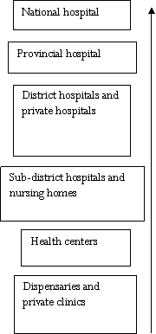
Kenya’s health system can be described as stepwise, with the more severe and complicated cases getting referred to higher levels. Both private and church backed units have filled any apparent gaps in the system. Under this system, dispensaries run by nurses and private clinics are the first and lowest point of contact for patients. These typically treat outpatient issues such as the flu, simple malaria symptoms and skin infections. Health centers are medium sized units typically catering to a population of up to 80,000 individuals. These have access to a very diverse and specialized staff, including pharmaceutical technologists and health officers. Health centers also have greater ability to provide services, and include in-patient wards where the very ill can stay and be treated. In addition, health centers also include diagnostic centers and pharmacies. At the higher level, each district within Kenya has a district hospital that is capable of handling most major medical and surgical procedures. These hospitals refer to one of 8 provincial hospitals that provide specialized care. At the national level, Kenya has two hospitals, the Moi Teaching and Referral Hospital and the Kenyatta National Hospital (Healthcare in Kenya).
Figure 4 KENYA’S HEALTH CARE SYSTEM
Governing the health system in Kenya is the Kenyan Ministry of Public Health and Sanitation and the Ministry of Medical Services. These two groups were once united as a single group, but split in 2008. The Ministry of Health runs 52% of the country’s health facilities (Rhatighan, 2009). To cover the cost of medical expenses, health insurance is available and two low cost schemes (provided by the National Health Insurance Fund and the Co-operative Insurance Company) were launched in June 2008. Both schemes attempt to attract subscribers beyond the traditional upper middle class segment. Still, private pre-paid insurance plans are only accessible to a small proportion of the population and the majority of all private expenditure is paid out of pocket. n November of 2009, it was announced that Kenya’s National Social Health Insurance fund, first proposed in 2005, would be reintroduced in 2010. This scheme requires that the government set aside money to contribute to healthcare expenses of the poor. In addition, wealthy Kenyans would be asked to contribute more money to this program in order to compensate for those more needy.

Through this system, poor Kenyans living on less than a dollar a day would be issued a card detailing their economic status which would serve as a waiver for all in and outpatient services in hospitals. The goal of the program is to shift away from patient self-medication due to lack of funds which previously had accounted for 40% of the population. Along with self-medication, the lack of access to public health facilities has caused many Kenyans to turn to unqualified village healers and herbalists who more often than not exacerbate a medical condition and pose a real threat to the health of the nation’s poorest. High costs of modern healthcare force 85% of Kenyans to turn to alternative medicine practitioners. Today, access to healthcare and quality of care remains a problem in Kenya as it is for most other African countries. 40% of rural households have difficulty accessing healthcare adequately. In addition, only a quarter of Kenyan facilities have access to water at all times and most do not have regular access to electricity (Rhatighan, 2009).

HIV AIDS and Tuberculosis are the major threats to health in Kenya. In the span of a little over 20 years AIDS cases in Africa have grown beyond proportion. In 2007, 2 million people in Kenya (7% of the population) were thought to be living with HIV AIDS, although many others were likely undiagnosed. HIV AIDS is most problematic in the Kakmeka region, where awareness of the disease is still very low, facilities are not well-established and local customs and at-risk behaviours continue to propagate the disease. Today, the major obstacles to decreasing incidence rates are still cultural resistance and lack of trained personnel (Rhatighan, 2009). In addition, more recently, the spread of what have been dubbed “e-pills” amongst teenagers in Kenya, emergency contraception pills, highly marketed especially to sexually active university-aged women, is increasing concerns about sexually irresponsible behaviour and the recurrence of fears of an epidemic of HIV AIDS (Mawathe).

In addition to HIV AIDS, Kenya is ranked as one of the countries with the highest TB burden. TB remains a concern largely due to the remaining stigma and discrimination associated with the disease. Many Kenyans still view TB to be a tightly associated symptom of HIV and when polled, 11% of Kenyans agreed that they would want a family member’s TB positive diagnosis kept secret. Encouraging Kenyans to get tested for TB in light of this environment thus remains a challenge. However, encouragingly, Kenya has also become one of the first countries to achieve certain detection and treatment targets set by the Stop TB partnership. Malaria is an equally serious problem which kills more Kenyans than any other communicable disease (Rhatighan, 2009). It is estimated that 70% of the population is susceptible to the threat of the disease. In addition, Kenya’s rainy seasons increases susceptibility, with large pool of water accumulating and creating fertile breeding sites for the mosquitoes. Today, malaria accounts for 30% of out-patient activities and 19% of admissions to health facilities. Malaria has severely impacted worker productivity in Kenya and also poses the problem of family and community erosion. Other prominent health issues that plague the country are gastroenteritis and diabetes (Healthcare in Kenya).

Today, diabetes is also on the rise in Kenya with an estimated 2 million individuals getting the disease every year. Experts estimate that this figure will likely rise to 10 million people in 2025, increasing the strain on Kenya’s already burdened healthcare system. The additional challenge with diabetes is the high cost of insulin and the cost to treat associated conditions such as hypertension. In addition, diagnosis remains a challenge as 60% of patients diagnosed with diabetes have been diagnosed on visits to the hospital for other complaints. Non-communicable diseases such as diabetes tend not to get a lot of attention from international donors, thus further complicating the issue of how to fund treatment for such a rapidly growing proportion of the population.

Maternal healthcare is on the rise in the country. The government, in response to new health challenges detailed in the UN’s “State of the World’s Children” report, issued in 2009, has instated additional vaccines which are integrated to cause less pain to the child and increased the vaccination period. In additional, in an attempt to further improve childhood care, the government has called for additional prevention efforts to thwart the transmission of mother-to child HIV. Medications are administered as soon as a mother is deemed to be positive and at risk of getting pregnant. In addition, more caesarean sections are conducted, which have been shown to lower the risk of transmission. Exclusive breastfeeding has also been encouraged, as it has been shown that mixing breastfeeding with other solid foods can irritate the digestive system and cause HIV to pass through intestinal walls.

Additionally, men have become more involved in the child-bearing process through the introduction of Lamaze classes in the country. Previously, due to the structure of the society in Kenya, men were though to the be the primary decision makers in the family, and therefore made the decision as to how many children his wife would have regardless of any family-planning methods suggested by doctors. Oftentimes, this would lead to decisions that would put the mother and child at risk. Lamaze classes have changed this approach, giving men a more acute appreciation for the process and thus increasing the dialogue between man and wife with regards to the health of the mother and baby.

Still, concerns about maternal health in Kenya are still at the forefront of concern for the country’s healthcare officials. Maternal mortality in the slums of Kenya stands at 706 deaths for every 100.000 live births with three fifths of these deaths occurring in women from the ages of 20-29. Deaths were largely attributed to unsafe abortion conducted by unqualified sources or miscarriage. Experts say that the source of these deaths can be largely attributed to three reasons 1) delay in recognizing a need for attention due to a complication 2) delay in deciding to bring a case to go to a health facility 3) delay in receipt of treatment once at a facility. Lack of appropriate infrastructure also contributes to the problem, as does lack of sufficiently trained medical professionals.

Shifting to infant health, a baby’s failure to thrive is of major concern. In the first few years of life, crucial to mental and physical development, monitoring a baby’s progress is of utmost concern to parents. In the first year, a baby’s brain will grow as much as it will grow for the rest of its life. Thus, proper nutrition during this time is essential. Ailments involving the food canal and chronic diarrhoea can severely impact the body’s ability to hold on to important nutrients. Urinary tract infections and cardiac and respiratory disorders can also strain the body and use up a lot of energy and nutrients quickly, diminishing appetite and stunting growth. Each of these conditions must be closely monitored in order to ensure normal growth patterns for children in impoverished countries where malnutrition is a concern.

Disease or health focus
The Nesbitt clinic is a general pediatrics clinic. While we are still developing a greater knowledge of the diseases / ailments that Dr. Nesbitt and his staff treat, our assumption is that most of these are similar to issues that would be found in pediatrics clinics in the United States.
From the information we have so far, the clinic sees patients with:
- Celiac disease
- Colic
- HPV
- Flu
In addition, the clinic administers Pneumococcal vaccine and conducts pre-natal consultations (Nesbitt Clinic)

Appendix
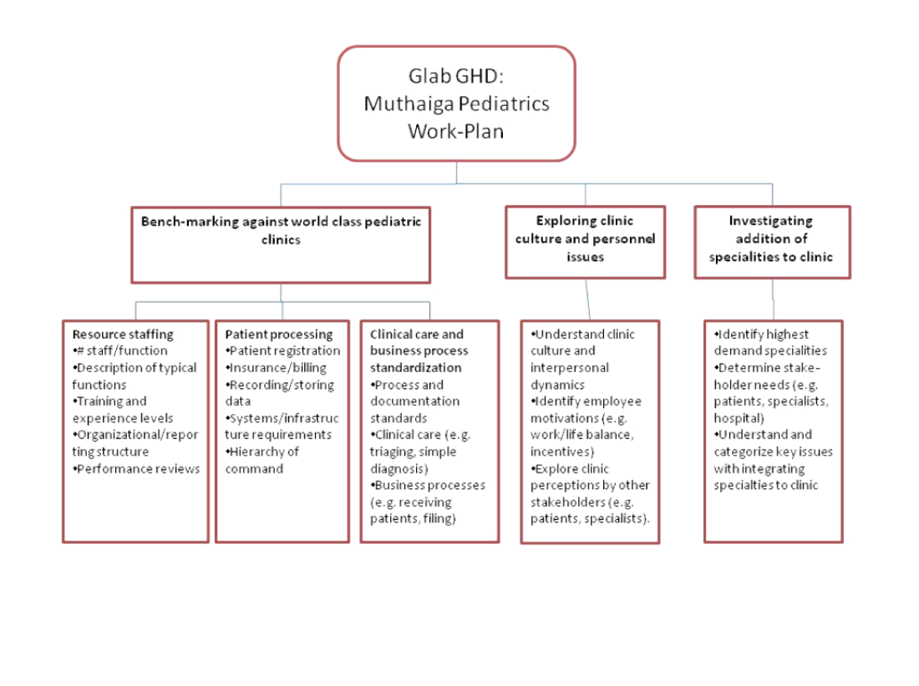
Figure 5 Work-Plan

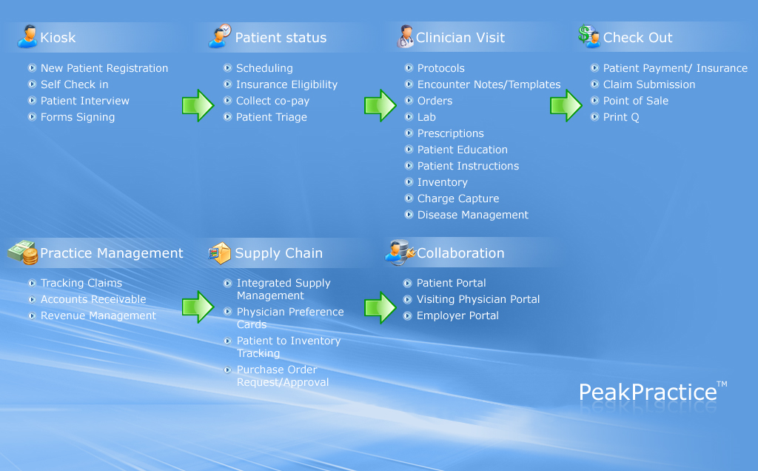
Figure 6 Schematic of services offered by peakpractice software
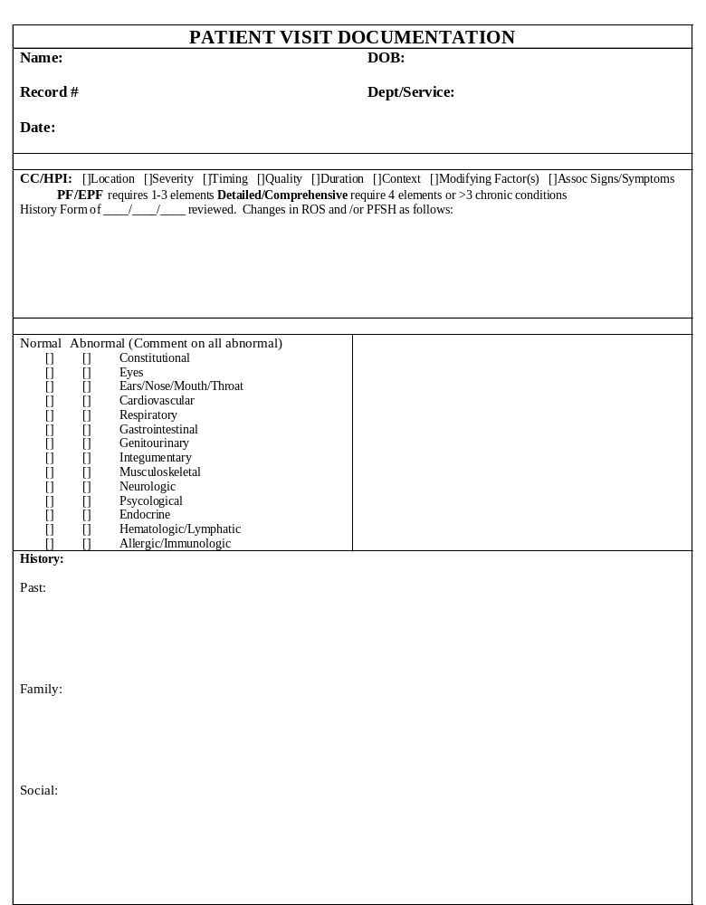
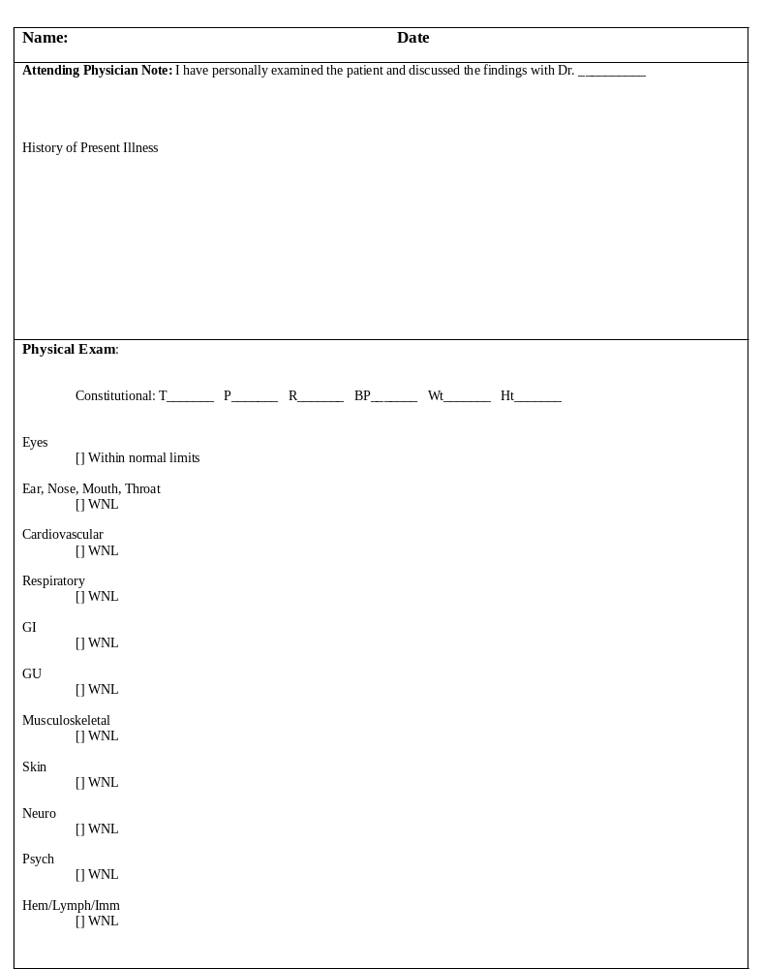
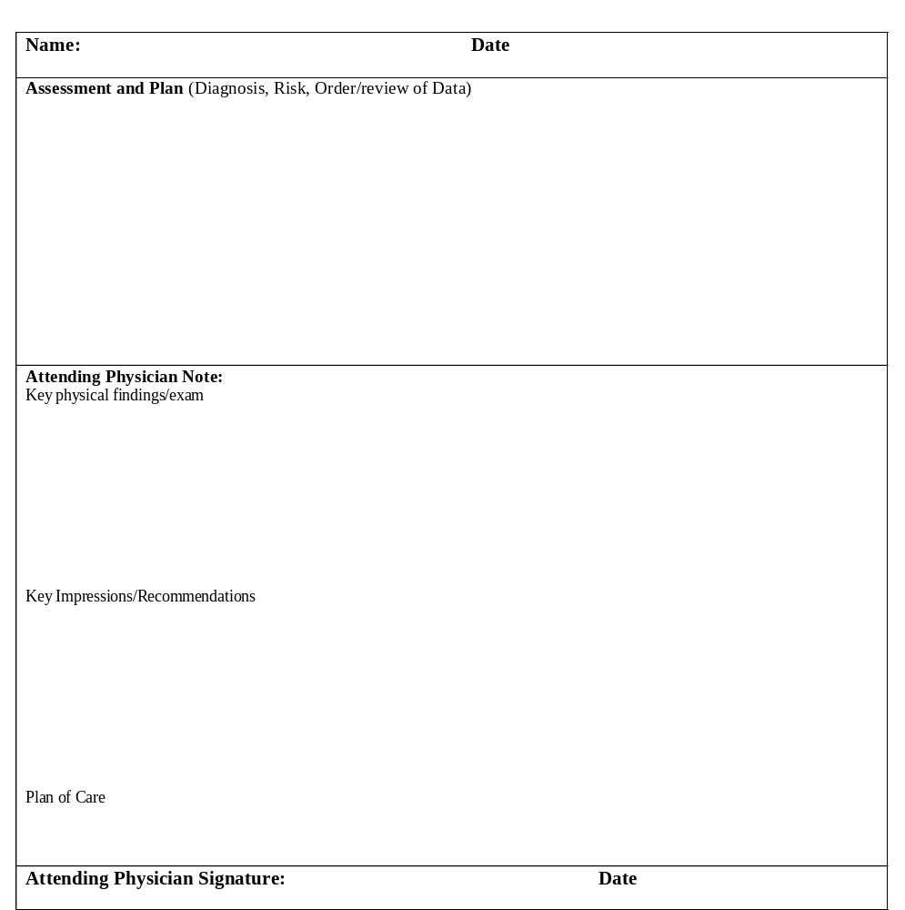 Figure 7 SAMPLE PATIENT VISIT DOCUMENTATION FORM

Interview framework

Patient Processing
- How did you initially go about setting up the current method for processing patients?
- How regularly do you change the process? Are such changes made as a result of a regular review or are they done only out of necessity due to an incident or change?
- Do you use metrics to track how efficient patients are processed? (e.g. average patient waiting time, number of patients seen in a day, number of patient complaints, number of errors – returned insurance papers, incorrectly scheduled appointments)
  - What metrics tools do you use? Excel sheets or Electronic Medical Record (EMR)?
- What is the largest source of patient processing errors? Missed appointments, incorrect billing, lost or incorrect files, etc.
- What best practices have emerged to minimize those errors?
  - How did you create these best practices (imported from other clinics/consultants; created by own staff; included in EMR system)
- What is the most time-consuming part of patient processing?
- What parts of the process require the most training/skills?
  - How do you go about training your staff?
- What parts of the process are better to consolidate (handled by only a few people) versus best handled by anyone?
- What advice would you offer to someone building a process from scratch?
- What role could/should technology play, ideally, in improving patient processing?
- Do you have an EMR in your practice? What brand do you have?
  - What challenges have you had in implementing it?
  - What benefits has it brought to your practice?

Clinical Care / Business Process Standardization

Documentation standards
- Regarding providing documentation to insurance providers, what appropriate billing and coding compliance programs are recommended?
- What software/systems are best recommended for registering new patients and tracking medical history/care?- Do you use an EMR for this?
- Are there appointment management systems that are recommended? i.e. follow up automated phone call reminders etc. Do you use an EMR for this?
- What practices are in place to ensure reliability/non-corruptibility of systems? i.e. making sure office does not rely on single laptop etc. Do you use a server with back up for your EMR for this?
- What are the standards for documentation that are legally required?

Clinical care standards (triaging, diagnosis)
- What standards exists for minimal patient turnover time (ie. what is the minimum time doctors need to properly see and diagnose a pediatric patient)
- What processes/staffing should be in place to improve efficiency of triaging ( by nurses and receptionists)
- What are the standards for patient /doctor flow (i.e. US system of nurses/physician assistants “preparing” patients for doctor)
- Processes for sharing equipment in small offices with few resources and more than one doctor

Business processes (receiving patients, filing)
- What is the optimal mix of payment schemes? Ex. Extending credit to patients, cash-only, insurance, pro-bono care
- What is the best way to stay on top of collections?
- Does your practice outsource most of its billing/or do your staff manage this themselves?
- How to combine more efficient use of staff and technology to relieve burden of work on doctors and decrease waiting time for patients
- Evolution of practice websites and how they can help increase patient flow by becoming “cyber-offices”
  - Does your practice allow for web/EMR server based bookings for “Non urgent appointments”?
  - Does your EMR allow for a patient portal at home or a patient kiosk in the clinic for “self check in”
Useful links:
- Clinical care guides provided by the American Academy of Pediatrics (by disease):
http://aappolicy.aappublications.org/practice_guidelines/index.dtl
- National Guideline clearinghouse – public resource for evidence based clinical guidelines: http://www.guideline.gov/ http://www.guideline.gov/browse/guideline_index.aspx
- A practice management journal: http://www.physicianspractice.com

Resource staffing:

General:
- How many staff members do you have in your clinic?
  - What are their roles?
  - Do you have a defined practice manager?
  - Do you use physician assistants?
  - Is your reception staff physician assistants/nurses or non clinical in training
  - Do your receptionists receive cash collections or do you have a separate cashier?
  - How many nurses do you have per doctor?
- Do you have an organizational chart that you could share with us (delete names if concerned about privacy, just want roles and reporting structure)?
- Do you have job descriptions (role/responsibility) documentation that you could share with us?
- How did you originally design your organizational structure at your clinic
  - Was it based on a model from previous experience?
  - Was it a recommended model by AAP?
  - Did it just “evolve” over time?
- If you were to start a new pediatric clinic, what things would you consider most important in designing your organizational structure?

Training and experience levels
- Can you please describe the required background experience, personal traits and training level for your key positions (e.g. new doc, secretary, nurse etc)?
- What additional training do you provide to new personnel?
- Can you describe the role (if any) of SOPs and/or a quality system in your training process?
- What institutional/academic guidelines (if any) do you follow with respect to training (e.g. does AAP provide guidelines)?
- What sort of continuing education do your provide to employees?

Performance reviews:
- Can you please describe your performance review process?
- Do you have any performance review forms/documentation that you could share with us?
- How are performance reviews perceived by different staff members in the clinic?
- Are reviews standard practice in medical clinics?
- How do you use performance reviews (e.g. to determine salary or promotion opportunities, to identify training opportunities etc)

Recruiting:
- Can you please describe your recruiting process?
  - In general
  - For specific job – like nurses or doctors
- What are your criteria for determining when you need to hire additional staff?
- Where do you advertise for new positions in your clinic?
- What has been your most important tool to help you recruit effectively?
- How important is word of mouth or referrals in recruiting for your clinic?
- When selecting pediatric physician candidates; what are your top 3 criteria (yrs experience, medical school attended, bedside manner etc.)?
- From your experience, what are the top 3 criteria used by pediatric physicians in deciding to join your practice?
- What are your biggest challenges in recruiting and maintaining pediatric physician and nursing talent to your clinic?

Subspecialties
- What specialty clinics would a general pediatric clinic refer patients to on a regular basis?
- Is it standard practice for general pediatric clinics to have links to specialists?
- Are these pediatric specialty clinics typically on-site?
  - Does your general pediatric clinic have pediatric subspecialists working in the clinic?
  - Do these pediatric subspecialists sharing administration, staff, space, etc?
- If the above answers are yes, how did this arrangement come about? At the founding of the clinic, or later? Driven by a need or an idea or a friendship?
- If the above answers are yes, how has the arrangement performed? Have any particularly stressful areas been identified? How were they resolved? Is the overall relationship friendly or icy?
- If any staffs are shared, does the arrangement stress the staff? Do they resent the extra work?
- What is the typical daily demand (per X patients) for specialist care? Does this need vary by other factors (demographics, location, closeness to a hospital)
- Which specialties typically have the highest demand?
- Do these sub-specialties typically compete with hospitals for patient care? Do hospitals welcome them? Would a hospital refer patients there as well?
- How many patients can they handle daily? How many patients (on average) do they need to care for to be profitable?
- Is there reluctance by other general pediatric clinics to refer patients to pediatric subspecialists who have their office in a group practice with general pediatricians?

Other services provided by clinic
- Does your clinic provide walk-in services?
  - Are these at beginning of day and end of day? (8- 9 am & 5-7 pm?)- “extended office hours”
  - Or do you run walk in clinics only during office hours?
  - If yes - do you find these walk in clinics take the pressure of your routine visit bookings OR do they just add extra strain on your staff?
- Does your clinic run specific vaccination sessions/days?
- Does your clinic run specific developmental check and school physical days?

Bibliography
(n.d.). Retrieved Oct 28, 09, from Muthaiga Country Club: http://www.mcc.co.ke/
About.com. (n.d.). Retrieved 10 28, 09, from A brief history of Kenya: http://africanhistory.about.com/od/kenya/p/KenyaHist.htm
Ahead of the Curve: Greenwood Pediatrics Uses PeakPractice to Connect, Improve Care. (2009). Eclypsis , pp. 9-11.
Healthcare in Kenya. (n.d.). Retrieved 10 28, 09, from Wikipedia: http://en.wikipedia.org/wiki/Healthcare_in_Kenya
Kenya Ethnic Groups. (n.d.). Retrieved Oct 28, 2009, from National Encyclopedia: http://www.nationsencyclopedia.com/Africa/Kenya-ETHNIC-GROUPS.html
Magical Kenya the Offical Kenya Travel Guide. (n.d.). Retrieved October 28, 2009, from http://www.magicalkenya.com.
Mawathe. (n.d.). Kenya concern over pill popping. Retrieved 10 28, 2009, from BBC: http://news.bbc.co.uk/2/hi/8145418.stm
Nesbitt Clinic. (n.d.). Retrieved Oct 28, 2009, from Nesbitt Clinic: http://www.muthaigapaediatrics.com/
Rhatighan, S. (2009). Kenya MPS Case.
The Whole Child Center. (n.d.). Retrieved November 24, 2009, from http://wholechildcenter.org
The Whole Child Center. (n.d.). Retrieved from athenahealth: http://wholechildcenter.org/diltwhilechild.html
Wikipedia Kenya. (n.d.). Retrieved Oct 18, 2009, from Wikipedia: http://en.wikipedia.org/wiki/Kenya
World Bank Kenya. (n.d.). Retrieved September 24, 08, from World Bank: www.worldbank.org

